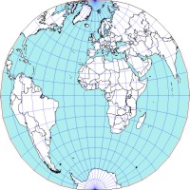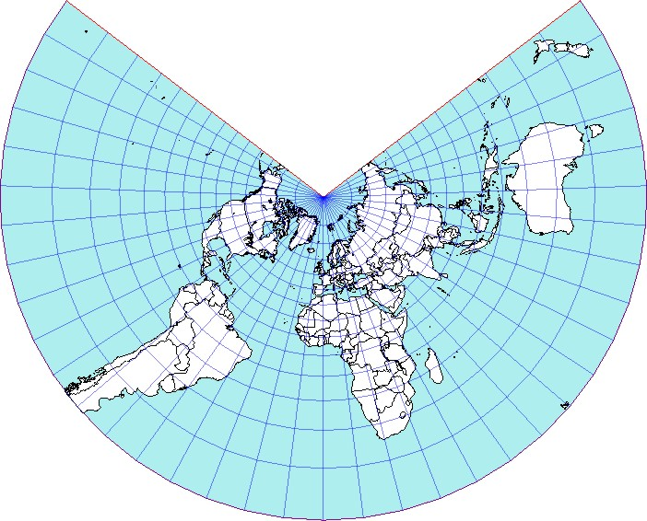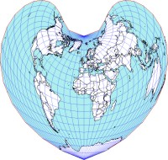

A&S Junior Seminar Proposal and Draft Syllabus
(one credit hour, grade awarded)

a path for Discovery:
Exploring another Country

Spring Quarter, 2010 ¤ 4:00-4:48 pm ¤ Thursdays
Thompson Library, Oval Mall, Room 165 (Multi-Purpose Room,1st floor)

Thompson 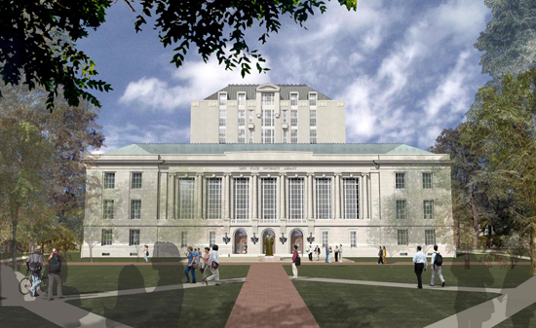 Library
The centrally located library has a:
- West entrance at 1858 Neil Avenue and
- East entrance on the Oval Mall

Instructor: Edward A. Riedinger, PhD
Phone: 688-8797
E-mail: riedinger.4@osu.edu
Office hours: by appointment

Class Members: _______

Class e-list: ______

Course Goals:
How much do international affairs, business, diplomacy, news interest you? Will you be enrolling in a Study Abroad program? Do you intend to take a “gap” year? Will your career involve international travel or living abroad? What is the place of the United States in the “global village.” The village is not a small place. Knowing other countries, one’s “neighbors,” offers an opportunity that is as vast as it is adventurous.

This course suggests a multi-point template one may apply for achieving an introductory knowledge of a country. The method employs a sequential integration of
- geographic,
- demographic,
- economic,
- socio-political, and
- historical factors.

outcomes for CLASS MEMBERS:
- use a template of parameters
- applied as a standard procedure
- to learn the basic profile of a country
- and communicate such information to others

resources for class
There is no textbook for this class. All documentation is from electronic sources that students can freely access or handouts that will be distributed by the instructor.

GRADE
Letter grade based on following criteria:
- Attendance at all classes
- Participation in all classes
- Presentation of country profile
Attendance is taken at each class and participation is noted. Participation means that a student makes relevant comments regarding assigned readings or tasks.
- “A” is granted to those who meet all the above criteria. (“A-“ for missing one class).
- “B” (two classes missed)
- “C” (three classes missed)
- “Incomplete,” project not completed or presented.

ClassES: Ten class sessions; each class one hour in length meeting once per week; awards one credits with letter grade. Course includes regular outside reading and research for class preparation.

presentationS: Class members prepare a group presentation, of 15 to 20 minutes length, that profiles a country based on the template of factors studied. Students determine the country they will profile. Profiles should include not only lecture but also audio, visual, electronic, and cartographic support materials.

PART ONE
Developing a Template: Sequence of Factors
Class 1
Introductions: Who, How, Where
Knowing each other and participating in the collaborative debate of a seminar. You are about to graduate and go “out into the world.” What’s there? How do you find out about it? What does and will globalization mean? What is your purpose in seeking information on a country? Travel, business, personal?
Assignment for next class:
See Physical World Atlas at http://www.sitesatlas.com/Atlas/PhysAtlas/
Peters Projection vs. Mercator Projection
A Gallery of Map Projections

Note: For the questions in the following classes, answers should be sought in relation to the country of Brazil. As information accumulates on it, a model will grow of how other country profiles can be formed and presented.
Class 2
The Physical Platform: Geography
Where does land rise and fall? Mountains, plateaus, valleys
Where and how does water flow? Rivers, lakes, seas
What does the land contain? Soils, vegetation, fauna, minerals
What is the environment? Climate, seasons, rainfall, temperature
Assignment:
Begin to use the The World Factbook at https://www.cia.gov/library/publications/the-world-factbook/

Class 3
Human Settlement(s): Demography
Where in this country are people settled? Are there differences? Are the differences ethnic, racial, religious, linguistic, cultural? What is the population pyramid?
Assignment:
See factors calculated in UN Human Development Index (HDI) at http://en.wikipedia.org/wiki/List_of_countries_by_Human_Development_Index
Quality of Life Index (QLI) at http://en.wikipedia.org/wiki/Quality-of-life_index
Understanding Gross Domestic Product (GDP) per capita: http://en.wikipedia.org/wiki/List_of_countries_by_GDP_(PPP)_per_capita

Class 4
Interaction of Population and Resources: Economics
What do people produce from this land? What are the portions of production by sector (primary/agriculture; secondary/manufacture; tertiary/service; quartenary/information)? How is production, how are goods and services, distributed among inhabitants?
Assignment:
See factors calculated in Corruption Perceptions Index (CPI) at http://www.transparency.org/news_room/in_focus/2008/cpi2008/cpi_2008_table

Class 5
Human Interactions: Society and Government
What are the means of control and stability (power)? What agents or agencies exercise power functions? Are these means accepted by all, most, or only part of the inhabitants? How widely distributed among inhabitants are decisions regarding exercise of power? Is power based on force, law, religion? A mix of these? What patterns of human behavior, or culture, exist?
Assignment: The character of a country by
Languages http://www.ethnologue.com/show_map.asp?name=World&seq=10 (Ethnologue)
Food http://allrecipes.com/Recipes/World-cuisine/Main.aspx (World Cuisine)
Music http://www.folkways.si.edu/searchresults.aspx?sPhrase=World&sType=cat (Smithsonian)

PART TWO
Applications of Template
Class 6
Country Profile Presentations by Class Members (in principle, two/three presentations scheduled per class)

Class 7
Country Profile Presentations by Class Members

Class 8
Country Profile Presentations by Class Members

Class 9
Country Profile Presentations by Class Members
Assignment:
See history sections of Countries of the World at http://www.infoplease.com/countries.html
International organizations: http://www.library.northwestern.edu/govinfo/resource/internat/igo.html

Class 10
Conditions over Time: History and the Future of Countries
How old is the country? How have past events determined current conditions? Have population, economic, and political changes occurred? Why? How?
In Conclusion
Do countries matter? What is a nation or a state? Do these entities have a future? What countries have recently appeared? Disappeared? What countries are joined in regional unions?

Academic Misconduct
“Academic misconduct” includes all forms of student academic misconduct wherever committed; illustrated by, but not limited to, cases of plagiarism and dishonest practices in connection with examinations, quizzes, reports, term papers, etc. All instances of alleged academic misconduct will be appropriately reported. Further information on misconduct is available in the Code of Student Conduct (http://studentaffairs.osu.edu/info_for_students/csc.asp).

Disability Services
Students with disabilities that have been certified by the Office for Disability Services will be appropriately accommodated, and should inform the instructor as soon as possible of their needs. The Office for Disability Services is located in 150 Pomerene Hall, 1760 Neil Avenue; telephone 292-3307, TDD 292-0901; http://www.ods.ohio-state.edu/.

BACKGROUND of INSTRUCTOR
Edward A. "Ted" Riedinger is a tenured full professor and the head of the Latin America, Hispanic, Spanish, and Portuguese Library Collection (LAT at http://library.osu.edu/sites/latinamerica) of Ohio State University (OSU). He is an adjunct professor in the Department of Spanish and Portuguese and the Department of History. Prof. Riedinger lived in Brazil for nearly two decades and is the author of numerous books and articles on the country in English and Portuguese. For further background information (education, experience, research grants, awards, etc.) see: http://library.osu.edu/sites/latinamerica/CVEdwardARiedinger.htm

